Test Case: tc002_SPX_Dev5_Crear_Requisicion_Spot_Tipo_Cobro_Project
Step 1 - Enter username and password and click to button Enter: Credentials Entered
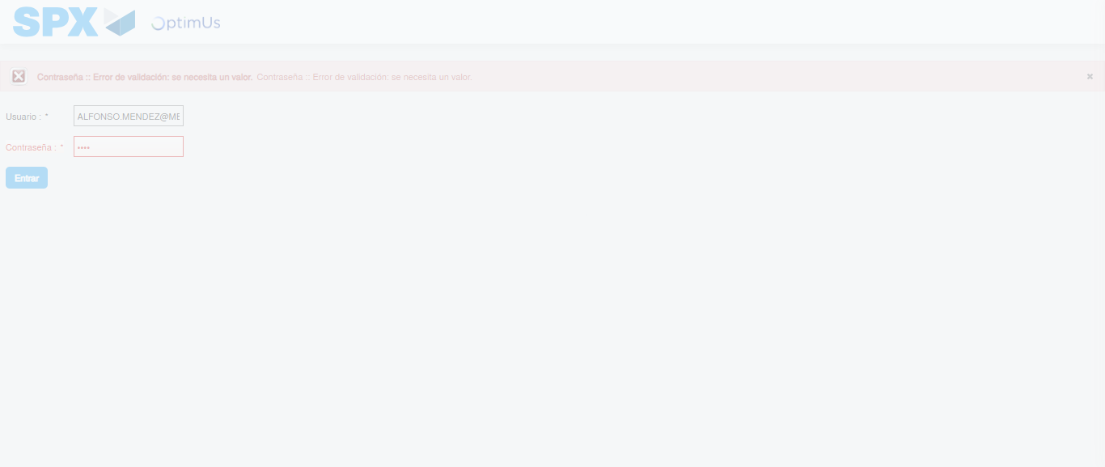Image file-name: QC_Testing-tc002_SPX_Dev5_Crear_Requisicion_Spot_Tipo_Cobro_Project-1783382184234

Step 2 - Select to UEN and Access to Spot Buy Requisitions : UEN Correctly selected and Correct access
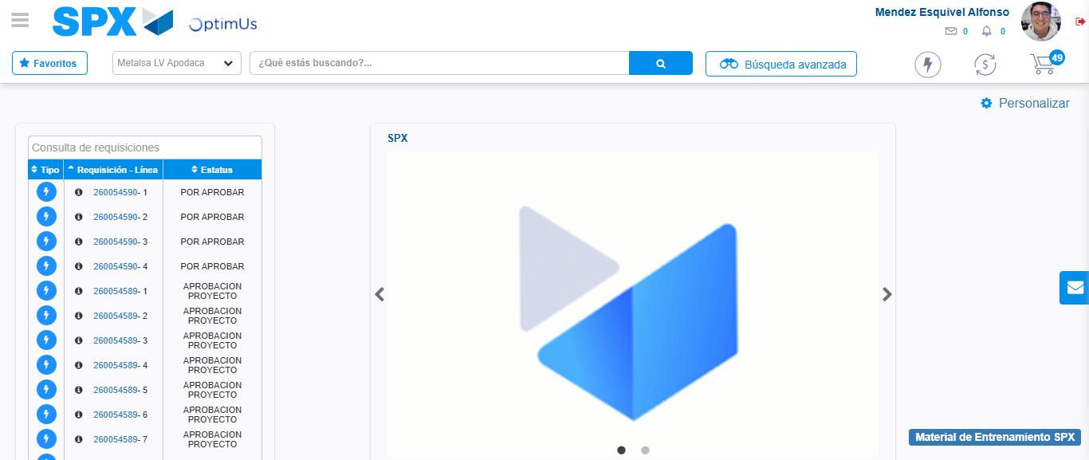Image file-name: QC_Testing-tc002_SPX_Dev5_Crear_Requisicion_Spot_Tipo_Cobro_Project-1783382209669

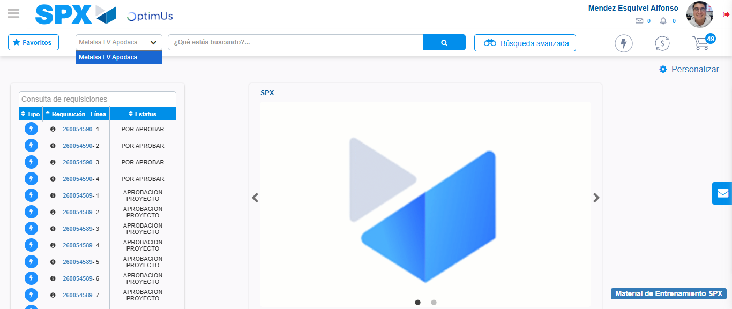Image file-name: QC_Testing-tc002_SPX_Dev5_Crear_Requisicion_Spot_Tipo_Cobro_Project-1783382212147

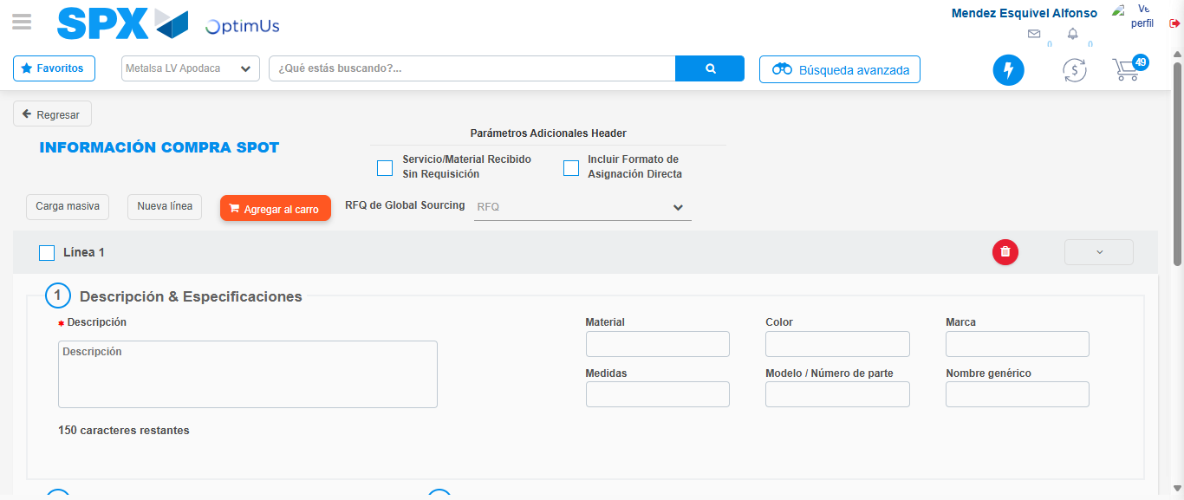Image file-name: QC_Testing-tc002_SPX_Dev5_Crear_Requisicion_Spot_Tipo_Cobro_Project-1783382234066

Step 3 - Data Capture Spot Buy Requisition: Data captured correctly
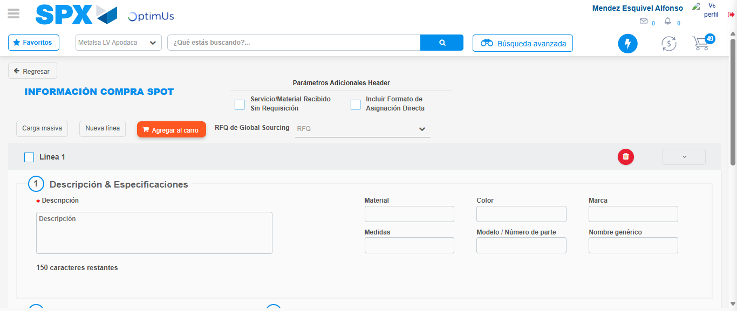Image file-name: QC_Testing-tc002_SPX_Dev5_Crear_Requisicion_Spot_Tipo_Cobro_Project-1783382234333

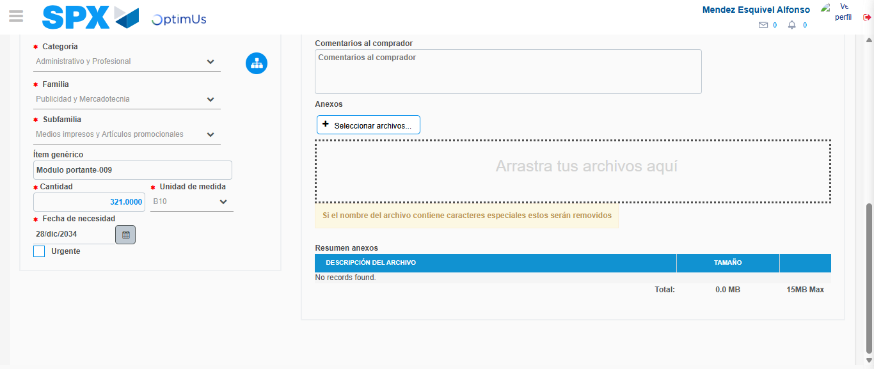Image file-name: QC_Testing-tc002_SPX_Dev5_Crear_Requisicion_Spot_Tipo_Cobro_Project-1783382243891

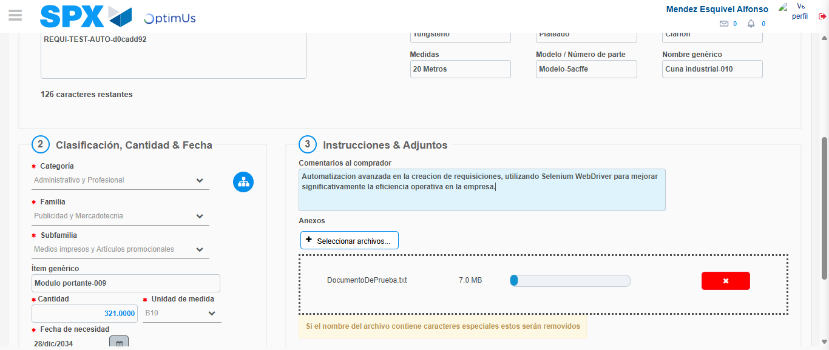Image file-name: QC_Testing-tc002_SPX_Dev5_Crear_Requisicion_Spot_Tipo_Cobro_Project-1783382244652

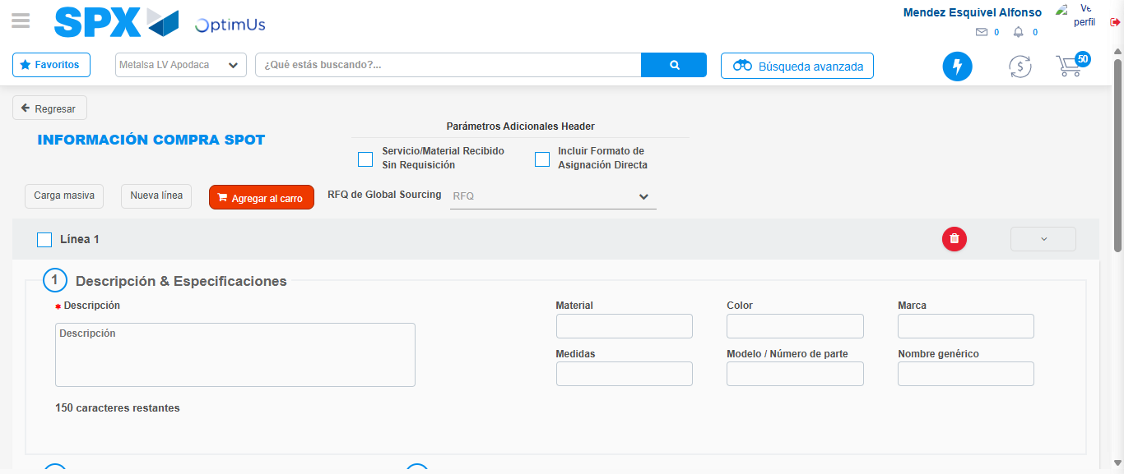Image file-name: QC_Testing-tc002_SPX_Dev5_Crear_Requisicion_Spot_Tipo_Cobro_Project-1783382254612

Step 7 - Return to Main Page SPX : Return to Main Page SPX
Image file-name: QC_Testing-tc002_SPX_Dev5_Crear_Requisicion_Spot_Tipo_Cobro_Project-1783382209669

Image file-name: QC_Testing-tc002_SPX_Dev5_Crear_Requisicion_Spot_Tipo_Cobro_Project-1783382212147

Image file-name: QC_Testing-tc002_SPX_Dev5_Crear_Requisicion_Spot_Tipo_Cobro_Project-1783382234066

Image file-name: QC_Testing-tc002_SPX_Dev5_Crear_Requisicion_Spot_Tipo_Cobro_Project-1783382256827

Image file-name: QC_Testing-tc002_SPX_Dev5_Crear_Requisicion_Spot_Tipo_Cobro_Project-1783382256981

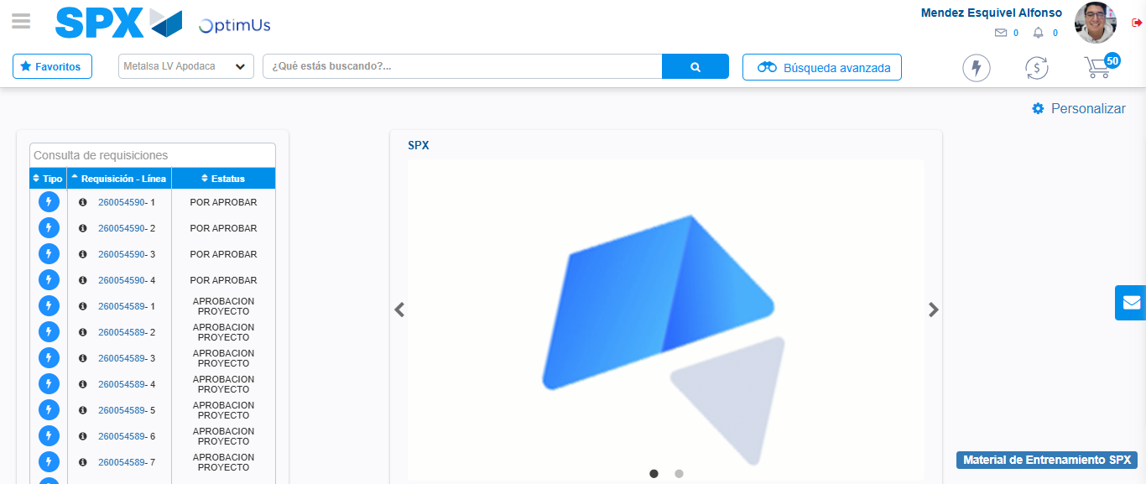Image file-name: QC_Testing-tc002_SPX_Dev5_Crear_Requisicion_Spot_Tipo_Cobro_Project-1783382278034

Step 8 - Log Out : Log Out SPX
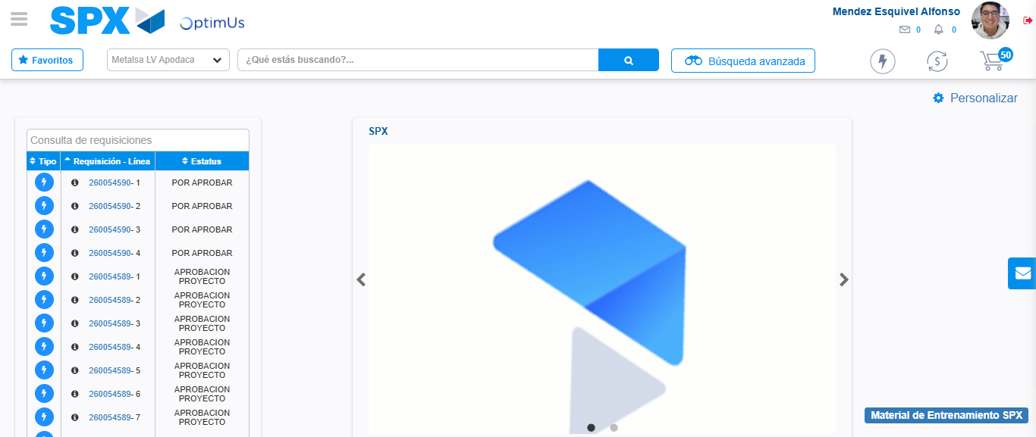Image file-name: QC_Testing-tc002_SPX_Dev5_Crear_Requisicion_Spot_Tipo_Cobro_Project-1783382278294

